

INTEGRA: DevelopINg Tailored comprEhensive services for younG migRAnts
Newsletter
March 2023

Capacity Building Programme in Marwadi University
The developed INTEGRA Capacity Building programme, which focuses on delivering ICT courses and psychosocial support services to young migrants, has also been delivered to staff of Marwadi University in India during November 2022! This capacity building programme has been designed by the expert partners from the EU (Harokopeio University, University of Porto, and Symplexis) and was delivered online to senior staff in Marwadi University from 2 to 10 November.
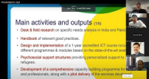
During the online training, the six participants (Dr Arjav Bavarva, Prof Vijay Dubey, Prof Chandrasinh Parmar, Dr Krunal Vaghela, Dr Rajeshkumar Joshi, and Prof Shakti Mehta) had the opportunity to get introduced to INTEGRA project and its objectives by Jorge Barbosa from the University of Porto, as well as to learn more about the developed Curricula Structure by Iraklis Varlamis from HUA, about the Learning methodologies and Psychosocial Support Training by Joao Moreira from UOP, and about Trainees Evaluation by Antonio Coelho.
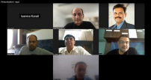
The goal of this training was to prepare the trainers for the entirety of the project, including its design, implementation, assessment, and sustainability, by providing guidance and support for the setup of the ICT and Psychosocial Support Centres in Marwadi University. After the successful completion of the Capacity Building Programme, its participants started passing down their newly acquired knowledge to their peers, as well as preparing for its pilot implementation.

The INTEGRA National Trainings continued!
Apart from the National Trainings in India and Pakistan that were organised last year, aiming to inform, educate and upskill the staff in the 4 participating HEIs on the INTEGRA scope and outcomes, an additional, 5-day National Training was organised by RK University from 4th to 9th of January 2023.
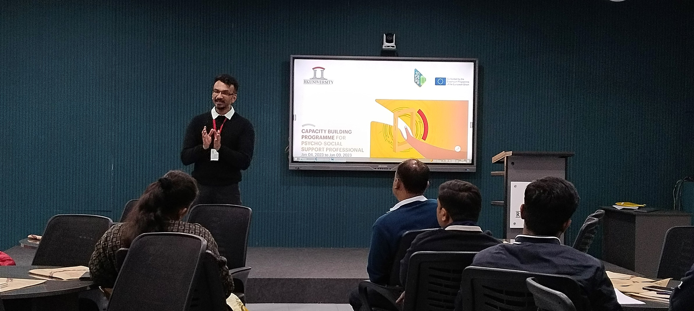
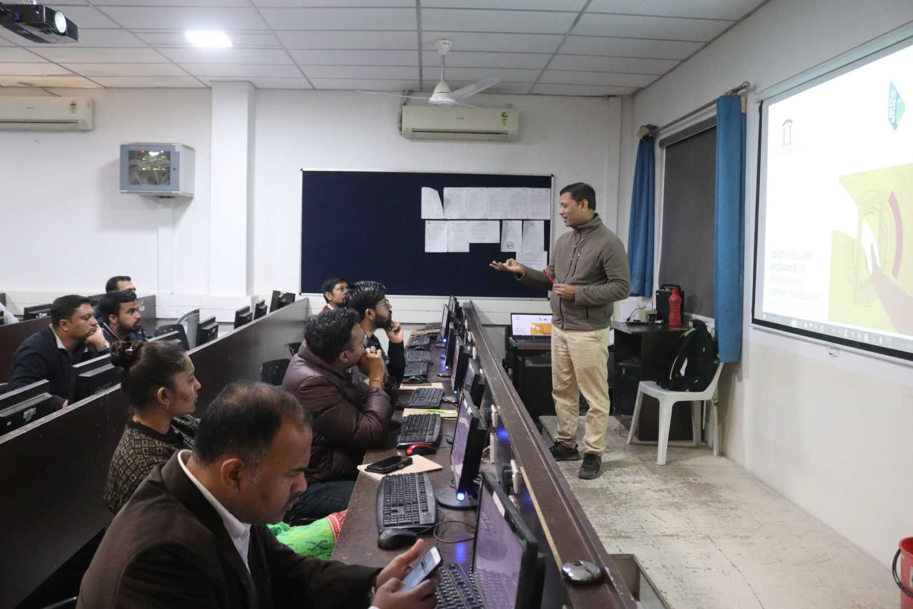
This National Training was focused on Psychosocial Training, during which aspiring instructors were given the opportunity to learn more about providing psychosocial assistance to migrant students and were also shown effective strategies from the European environment. Apart from an overall introduction to INTEGRA, Fundamentals of Psychology were also considered, including principles of psychosocial assistance, guidelines for encouraging mutual support, and advice on trauma-informed practices. During the training, issues of Intercultural Understanding and Social Inclusion, as well as organisational elements of the functioning of the Psychosocial Support Structures were also covered.

Pilot Implementation
The INTEGRA Pilot Implementation phase has commenced! After having been successfully trained in ICT and Psychosocial Support Issues, staff from HEIs in India and Pakistan have started providing these courses and resources to refugee and migrant students. The piloting activities will allow for the ICT course to be tested and refined, in order to guarantee that the learning modules are relevant and useful in upgrading the end-users’ ICT skills, and in improving the knowledge and competencies of ICT professionals. The same applies for the developed psychosocial support services, whose impact and effectiveness will be assessed by young refugees – the actual recipients of the services.
The first step was the identification and preparation of potential trainees in the 4 HEIs, which has been achieved through an initial call for interested participants (refugee students and alumni, refugee/migrant associations & NGOs in India and Pakistan) and their subsequent selection based on a set of criteria, such as level of motivation, eagerness to work for the ICT sector, existence of psychological traumas etc. After their selection, participants are introduced to the project and the developed curricula for ICT and Psychosocial Support.
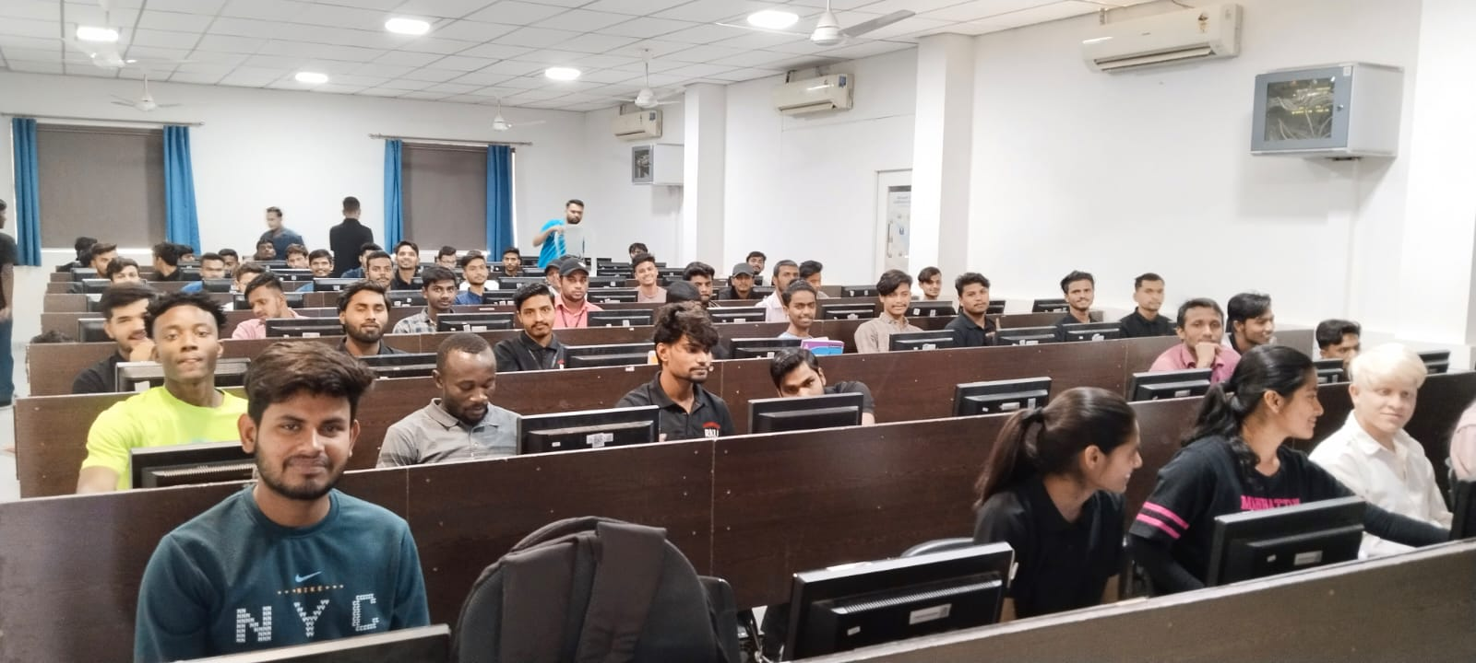
RK University in India has already held an awareness session, aimed at giving test users a complete overview of the courses, as well as presenting and using the dedicated Moodle platform.
Test users during the Awareness Day at RK University
Moreover, RK University has also started delivering presentations on the developed ICT courses to migrant and refugee students within the institution. Additionally, 20 Sri Lankan students interested in enhancing their ICT skills, but also in learning how to receive psychosocial support and help their peers if needed are being trained online during March 2023.
The piloting activities in RK University will continue in the next months, to cover all developed materials and receive feedback from the test users about their relevance and appropriateness.

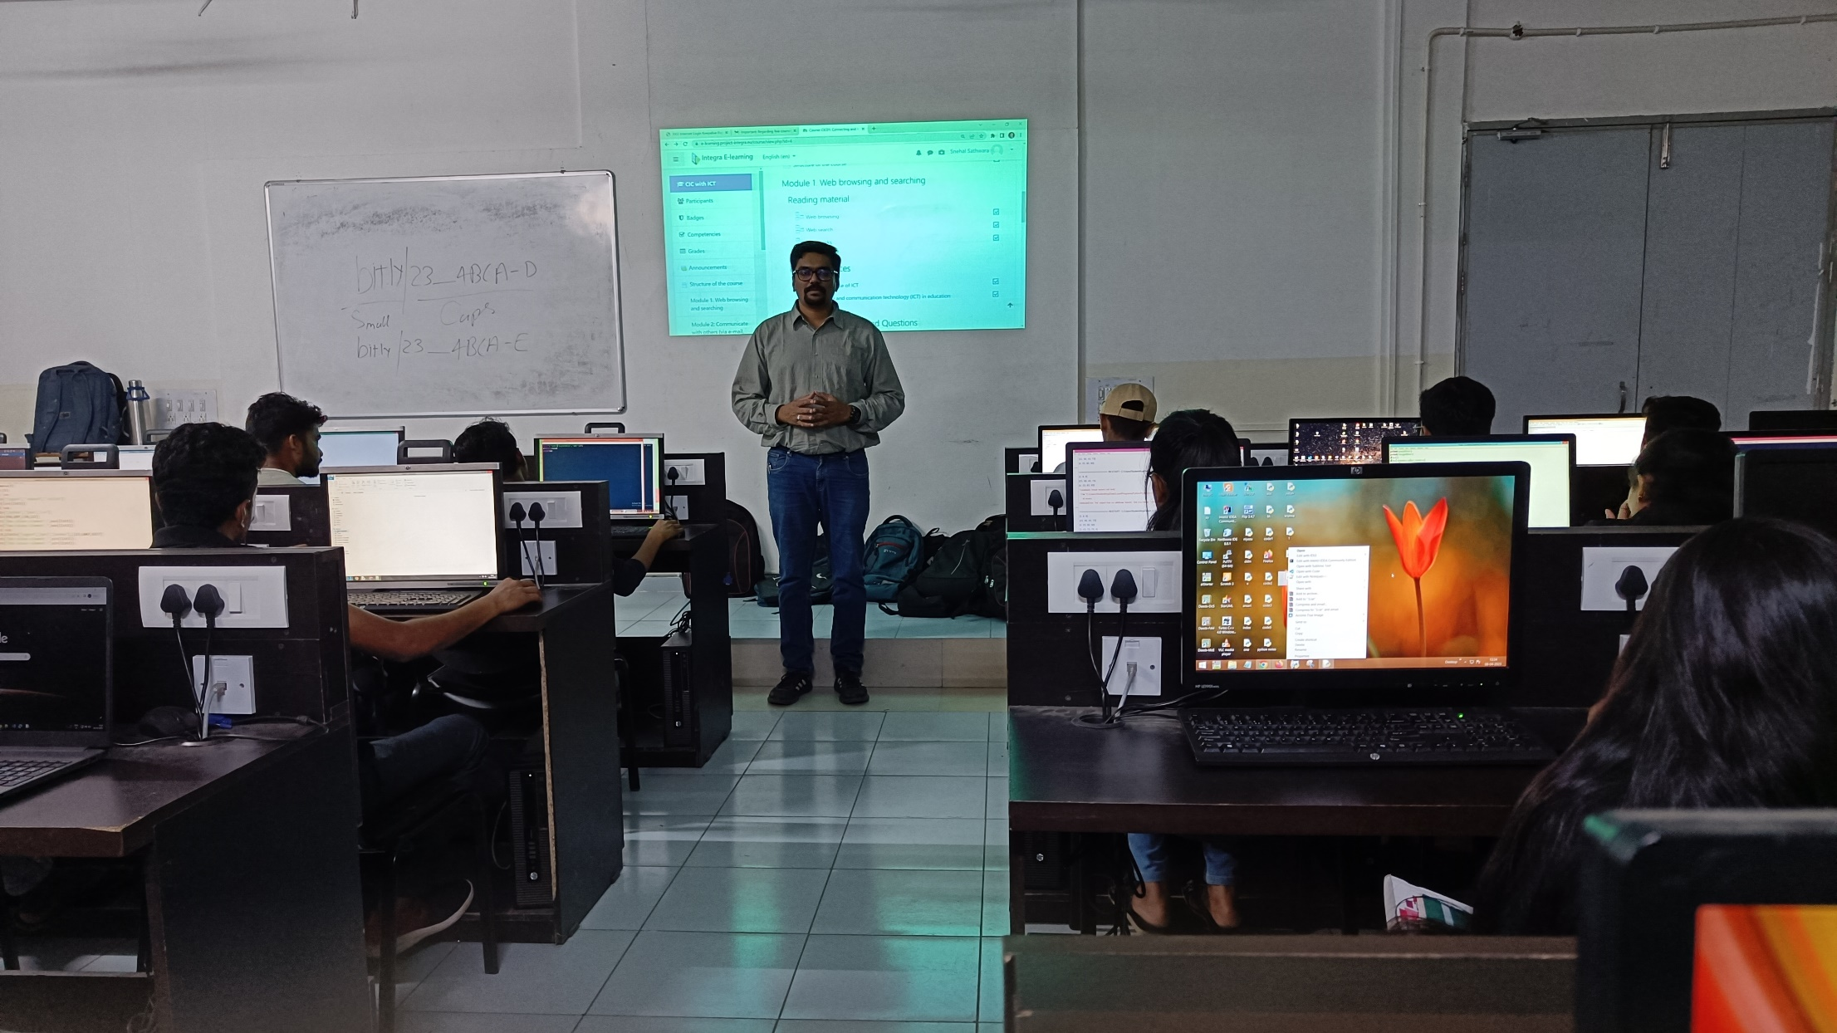

Test users during an ICT pilot course at RK University

Lahore University of Management Sciences (LUMS) in Pakistan has also started implementing pilot activities with test users (migrant/refugee students) in the past couple of months. The activities are expected to carry on in the next months, in accordance with exam periods and holidays.
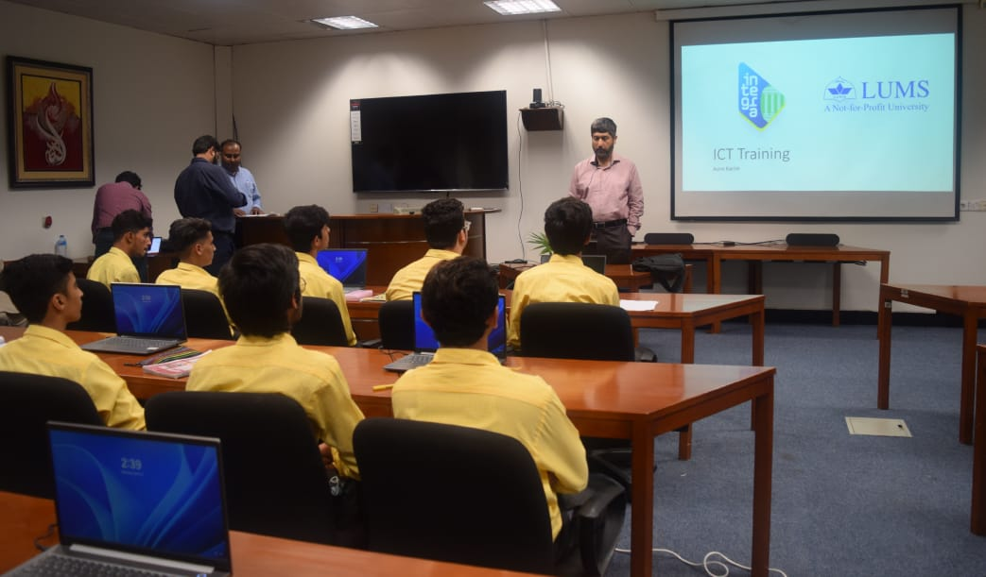

The pilot trainings are undergoing in the rest of the HEIs as well and are expected to continue so throughout spring! Stay tuned to learn more!

Next steps
As the implementation of piloting activities continues, monitoring visits will be organised and carried out in the following months, during which representatives of the EU partners (Harokopeio University, University of Porto, and Symplexis) will visit the 4 HEIs in Asia, monitor the operation of the developed ICT and Psychosocial Support Centres, and offer guidance and mentoring for their improvement and sustained functioning.


If you want to get involved in the project, visit our website (https://project-integra.eu) or Facebook Page (https://www.facebook.com/Integra.EU.Project) and send us a message or contact one of your in-country partners to find out more!
Partners

